

**Rovers Floating Launcher**

Review Guide

**Rovers for Android**

**Requires:** Android 4.0.3 **Price:** Free (with IAP)

[Website](https://schiztech.com/app/rovers) | [Google Play](https://play.google.com/store/apps/details?id=com.schiztech.rovers.app)

For any assistance, press & interview inquiries please contact

Dor Yehuda, SchizTech

[dor@schiztech.com](mailto:dor@schiztech.com) | (+1) 914 3364890



**SchizTech Studio**

**What’s Rovers?**

Rovers is the floating launcher that will change the way you use your device.

Imagine you could go to any of your favorite apps with a single click, from anywhere, whether you’re currently playing Candy Crush or checking the news online. That’s Rovers, always there for you, above any other app, waiting for your call. You’ll always be just one-click away from your favorite apps, shortcuts and actions.

Rovers was designed to match the main Android style guidelines in order to blend in perfectly, as if it was a part of your Android experience all along.

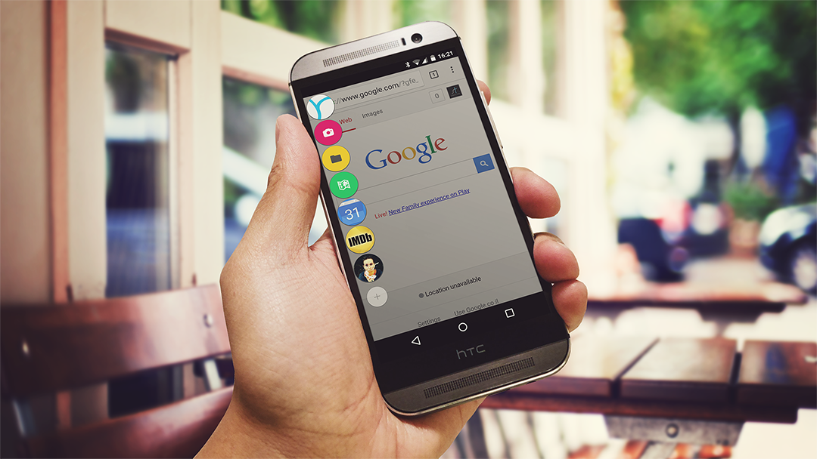

Rovers has many customization options that allow you to make your Rovers experience unique, with thousands of possible colors & icons combinations for each Rover item.

**Rovers Features**

A Floating Launcher

Rovers will float around your screen, above other applications, waiting for your call. Rovers’ trigger can be moved around so it won’t interrupt your regular use.

Customization Options

With over 200 colors and 300 icons you can customize every Rover item in a unique way. Moreover, the floating trigger can be styled via the settings screen.

Launch Modes

Using a tablet? We’ve got you covered! Rovers can be launched horizontally & vertically. Want Rovers to always launch on a specific corner? There’s a “Sticky Corner” option in the settings just for that.

Organize Your Rovers

Use folders to keep your Rover items organized and quickly accessible.

Edit Mode

If you’re not pleased with the current Rover items list that you’ve got, long click on any Rover item, it will launch the ‘Edit-Mode’. In the ‘Edit-Mode’ you can simply drag items to relocate them or slide them away to remove them.

Rovers Actions

We’ve saved the best for last. Rovers Actions are basically one-click action that will make your life easier, such as:

Floating app drawer • RAM Cleaner • Flashlight trigger • Direct Call • Settings Toggles & more.

Oh, yeah… We’ve built an opened Rovers Actions API for Android developers, it can be found here: <http://roversapi.schiztech.com>

**FAQs**

How much does Rovers cost?

Rovers is free, with 3 in-app purchases available:

* Change each Rovers item’s color (0.99¢)
* Floating trigger customization settings (0.99¢)
* Unlimited amount of Rovers (0.99¢)

There’s also a package that includes all 3 for $2.49.

What are the System Requirements for Rovers?

Rovers requires Android 4.0.3 and above.

**More Questions?**

For any more questions about Rovers, please contact Dor Yehuda, Founder of SchizTech Studio at [dor@schiztech.com](mailto:dor@schiztech.com).

We also have a limited amount of Promotional Codes for Rovers available for press review purposes, so that you can try out Rovers with all of its features.

**Useful Links**

Rovers on Google Play

<https://play.google.com/store/apps/details?id=com.schiztech.rovers.app>

Rovers Website

<https://schiztech.com/app/rovers>

Rovers Press Kit

<https://goo.gl/QHhMtJ>

SchizTech Studio Website

<https://schiztech.com>

SchizTech Studio on Twitter

<https://twitter.com/SchizTech>